### **CHAPTER 1**

### **COMPANY PROFILE**

### **CHAPTER 2**

### **ABOUT THE DEPARTMENT**

### **CHAPTER 3**

### **TASKS PERFORMED**

**3.1 FRONTEND DEVELOPMENT**

* **HTML:** Hyper Text Markup Language forms the backbone of any web application, including those built with Spring Boot. It serves as the structural framework, defining the content and layout of a webpage. HTML consists of various elements such as headings, paragraphs, lists, images, tables, and forms, which help organize information in a meaningful way. It uses tags to mark different components of a webpage, ensuring they are properly displayed in browsers. In a Spring Boot application, HTML can be used with templating engines like Thymeleaf, which allows dynamic content rendering by embedding Java logic within the markup. This enables developers to create reusable and interactive web pages while integrating data from backend services efficiently.
* **CSS:** Cascading Style Sheets is responsible for styling and enhancing the visual appeal of a web application. It controls aspects such as colors, fonts, spacing, positioning, and responsiveness, ensuring an intuitive user experience across different devices. CSS can be written inline, within a tag in an HTML document, or externally in a separate stylesheet. Spring Boot applications often use CSS to style static HTML files or dynamically rendered pages. Additionally, modern CSS frameworks like Bootstrap or Tailwind CSS can be integrated to provide pre-designed components and utility classes, reducing development time while maintaining a professional and consistent design.
* **JavaScript:** Is a powerful scripting language that adds interactivity and dynamic behaviour to web applications. It enables functionalities such as user input validation, animations, event handling, and asynchronous communication with backend APIs. In a Spring Boot application, JavaScript can be used to interact with RESTful services, fetching data from the server and updating the webpage without requiring a full reload. This is commonly achieved using AJAX or modern frontend frameworks like React, Angular, or Vue.js, which enhance the application’s interactivity. JavaScript’s ability to manipulate the Document Object Model (DOM) allows developers to create smooth user experiences, making it an indispensable tool in modern web development.

**3.2 BACKEND DEVELOPMENT**

A backend Spring Boot application using Maven for web development provides a robust and scalable framework for building enterprise-grade applications. Spring Boot simplifies the development process by offering built-in configurations, auto-configuration, and dependency management, making it easier to create production-ready applications with minimal setup. Maven acts as the project management tool, handling dependencies, build lifecycle, and packaging. In a typical Spring Boot web application, Maven manages libraries such as Spring Web for handling HTTP requests, Spring Data for database interactions, and Thymeleaf or RESTful services for communication between frontend and backend. The Spring Boot framework includes an embedded Tomcat server, allowing developers to run the application without requiring additional deployment configurations. The application follows a layered architecture, where controllers process requests, services contain business logic, and repositories manage data persistence with JPA or Hibernate. With Maven’s dependency management, developers can easily integrate authentication, logging, and third-party APIs, streamlining the development process. Additionally, Spring Boot provides extensive support for RESTful APIs, enabling seamless interaction between the frontend and backend through JSON-based communication. By combining Spring Boot with Maven, developers can build secure, scalable, and efficient web applications that are well-suited for modern software development.

**3.3 DATABASE MANAGEMENT**

In a Spring Boot application, MySQL database management using XAMPP provides a flexible and efficient approach for handling data. XAMPP is a local server environment that includes MySQL, Apache, and PHPMyAdmin, making database administration and development more convenient. MySQL serves as the database system, storing structured data and enabling efficient retrieval and manipulation using SQL queries. Spring Boot integrates with MySQL seamlessly through JPA (Java Persistence API) and hibernate, allowing developers to interact with the database using object-relational mapping (ORM). By configuring the application. properties or application.yml file, developers specify the database connection details, including the MySQL driver, username, password, and schema. The application can then define entity classes representing database tables and use Spring Data JPA repositories to perform CRUD (Create, Read, Update, Delete) operations effortlessly. With XAMPP, MySQL can be managed using PHPMyAdmin, providing a user-friendly graphical interface for handling tables, queries, and database users. Additionally, Spring Boot applications often use RESTful APIs to retrieve and store data dynamically, ensuring seamless interaction between the backend and frontend. By leveraging MySQL with XAMPP in Spring Boot, developers gain a robust and efficient way to manage data for web applications, enhancing performance, scalability, and usability.

### **CHAPTER 4**

### **REFLECTION NOTES**

**4.1 EXPERIENCE**

INDO Contact Management is an online platform developed to assist business professionals, sales teams, and individual users in storing, managing, and organizing product and contact information efficiently. The webpage opens with a brief slideshow advertisement that introduces the platform's purpose and features, creating a strong first impression. It supports multiple categories, allowing users from various industries to participate. The platform requires users to register using a valid phone number or email address and a password, ensuring a secure login process. After logging in, users must fill out a detailed form that includes information such as the industry name, location, products manufactured, a description of their industry, years of experience, and contact details. For buyers interested in bulk purchases, the platform offers a free trial for the first contact; thereafter, they are required to register and pay a set fee. A dedicated payment page is provided for every buyer registration. Overall, the system provides a structured and user-friendly interface with clear functionality. However, the user experience could be enhanced with better clarity on user roles and added features such as contact history and verification. INDO Contact Management stands as a promising tool for bridging the gap between manufacturers and bulk buyers in a secure and organized manner.

.

**4.2 TECHNICAL OUTCOMES**

**4.2.1 SYSTEM REQUIREMENT SPECIFICATION**

**4.2.2 HARDWARE REQUIREMENTS**

* Processor: Intel i5 or above (Quad-core recommended)
* Hard Disk: 100 GB (minimum)
* Memory (RAM): 8 GB (minimum), 16 GB recommended
  + 1. **SOFTWARE REQUIREMENTS**
* Web Server: Embedded Apache Tomcat (included with Spring Boot)
* Operating System: Windows
* Platform: Java 17+, Spring Boot Framework
* Build Tool: Maven
* Frontend Technologies: HTML5, CSS3, JavaScript
* IDE (Editor): VS Code
* Database: MySQL / PostgreSQL / H2 (for development)
* JDK: Java Development Kit 17 or later

**4.3 SYSTEM ANALYSIS AND DESIGN**

**4.3.1 EXISTING SYSTEM**

The existing system for managing contacts and product information in businesses, particularly in manufacturing and sales sectors, is largely manual and fragmented. Most companies rely on spreadsheets, handwritten records, or basic digital tools that are not specialized for industry needs. There is no centralized platform to systematically store and organize details such as product categories, company profiles, or buyer interactions. Registration and communication between manufacturers and buyers often happen informally through email or phone calls, leading to inconsistent record-keeping and a lack of data security. Additionally, there is no structured login or authentication process, making it difficult to verify users and protect sensitive information. Bulk buyers searching for manufacturers typically rely on offline sources, trade fairs, or generic online searches, which can be inefficient and unreliable. There is also no provision for offering limited access or managing payments for contact information, making it hard to monetize such services. Overall, the existing system lacks automation, scalability, and security, making it inefficient for modern business networking and contact management.

* + 1. **DISADVANTAGES OF THE EXISTING SYSTEM**

1. **Lack of automation:** Manual data entry is time-consuming and prone to errors.
2. **Scattered information:** Data is stored in multiple places (spreadsheets, emails, physical files), making it hard to manage.
3. **No centralized platform:** Difficult to organize, search, or update contact and product information efficiently.
4. **Poor data security:** Without proper login or authentication, sensitive information is at risk of unauthorized access.
5. **Limited communication efficiency:** Buyers and sellers rely on informal methods like phone calls or emails, leading to miscommunication.
6. **No verification process:** Difficult to confirm the authenticity of users or businesses.

**4.3.3 PROPOSED SYSTEM**

The proposed INDO Contact Management system is a web-based platform designed to streamline the management and exchange of product and contact information between manufacturers and bulk buyers. It addresses the inefficiencies of traditional contact management systems, which often rely on scattered data, manual processes, and lack of security. The platform begins with an engaging slideshow that introduces its features, and it supports multiple categories for easy navigation, allowing businesses to list their products in relevant sectors. Users must register with a valid phone number or email and create a secure password. After logging in, users complete a detailed profile with information such as business name, industry, product offerings, location, experience, and contact details. This structured profile system ensures professionalism and reliability. One of the platform’s standout features is its approach to connecting manufacturers and buyers. Bulk buyers are offered a free trial contact with a manufacturer, giving them a chance to evaluate the platform before committing. After the trial, buyers are required to register and pay to access further contacts, creating a sustainable revenue model.

The platform includes a secure payment gateway that allows for easy, transparent transactions, providing both manufacturers and buyers with a seamless experience. By centralizing communication within the platform, the system reduces miscommunication and enhances the efficiency of business networking. The user interface is designed to be intuitive, responsive, and accessible on various devices. Scalability is a key feature, allowing the system to accommodate growth as more users and data are added.

**4.3.4 ADVANTAGES OF THE PROPOSED SYSTEM**

1. **Centralized Platform:** All user and product information are stored in one place, making management and access efficient and organized.
2. **Secure Registration and Login:** Authentication through email or phone number ensures user identity verification and enhances data security.
3. **Detailed Business Profiles:** Users can showcase their industry name, location, products, experience, and contact information, improving transparency and professionalism.
4. **Categorized Listings:** Products and businesses are organized into multiple categories, making it easier for users to find what they need.
5. **User-Friendly Interface:** Clean design and intuitive navigation provide a smooth user experience across all devices.
6. **Free Trial for Buyers:** Allows potential investors or bulk buyers to explore the platform with a limited free contact, encouraging new user engagement.

**4.4 SYSTEM ARCHITECTURE**

**4.4.1 DATA FLOW DIAGRAM**

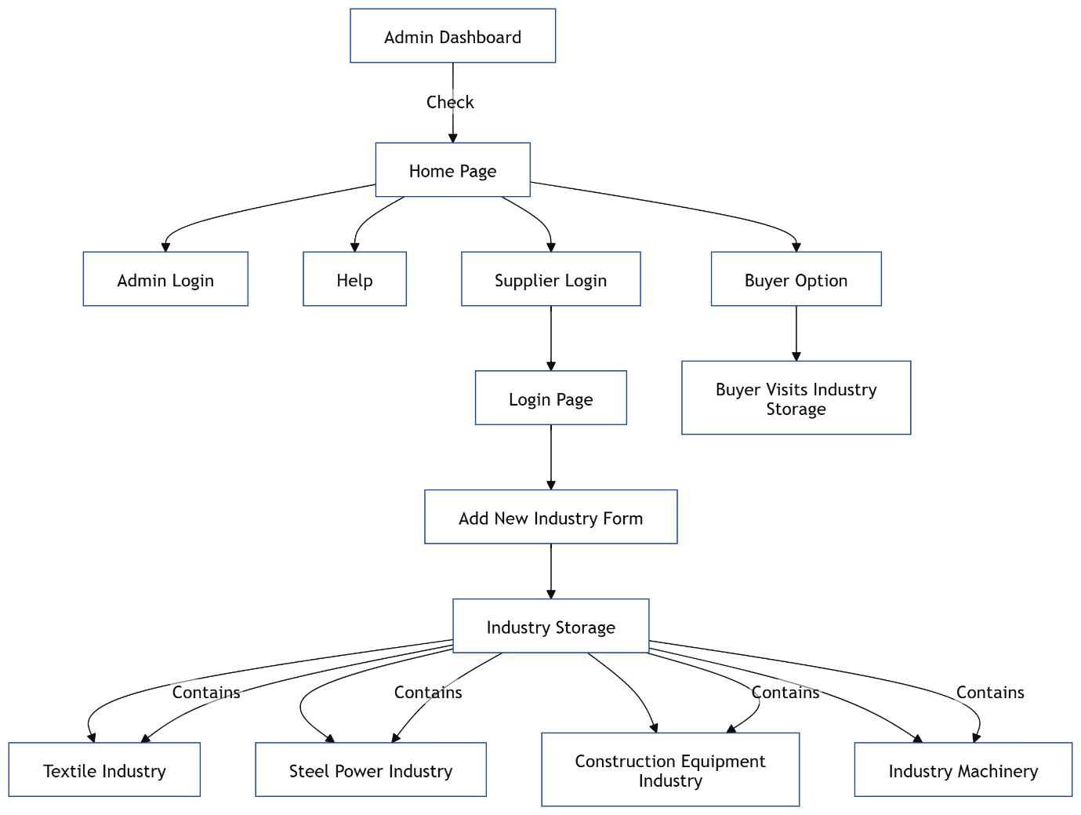

**Fig 4.4.1 Data Flow Diagram**

**4.4.2 UML DIAGRAM**

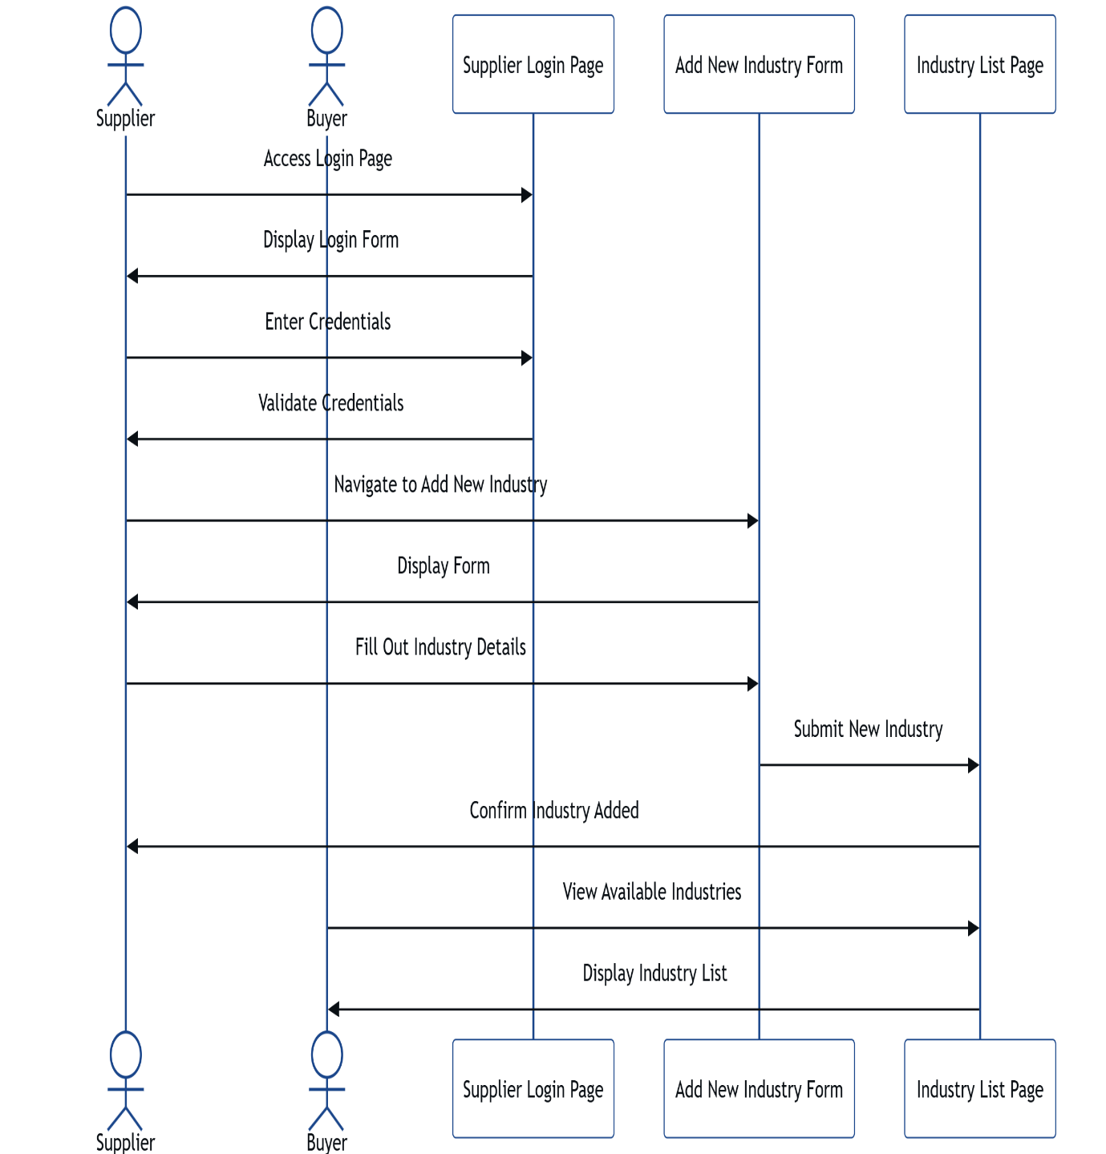

**Fig 4.4.2 UML Diagram**

**4.4.3 USE CASE DIAGRAM**

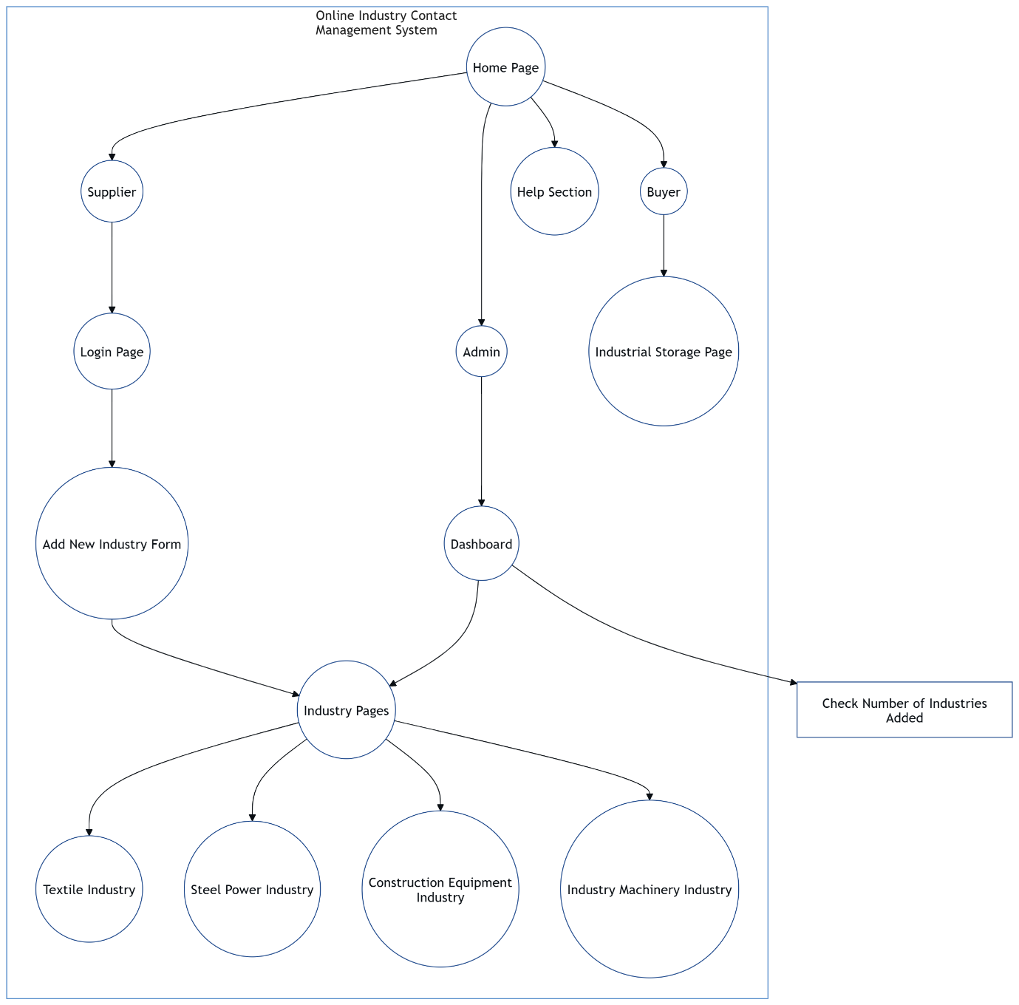

**Fig 4.4.3 Use Case Diagram**

**4.4.4 CLASS DIAGRAM**

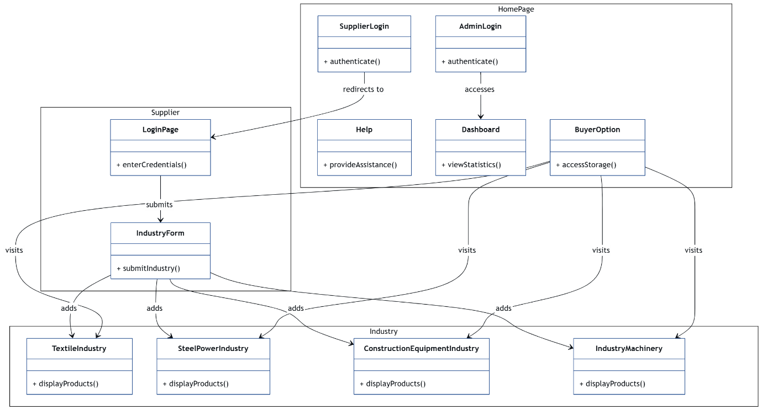

**Fig 4.4.4 Class Diagram**

**4.4.5 SEQUENCE DIAGRAM**

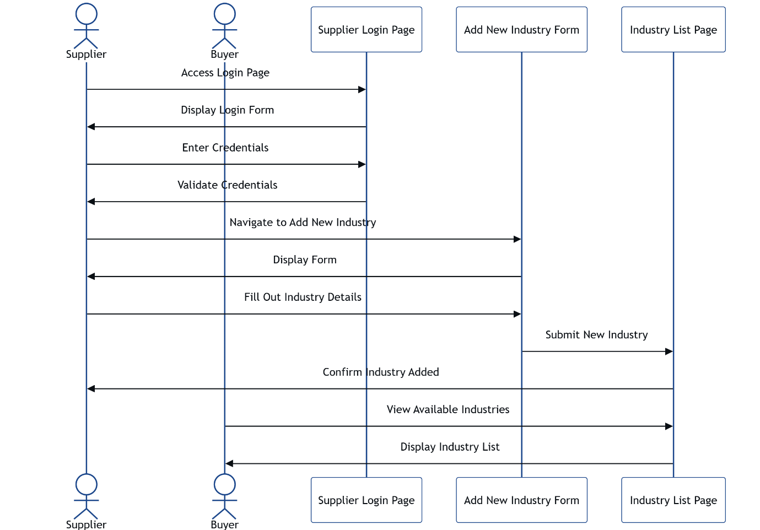

**Fig 4.4.5 Sequence Diagram**

**4.4.6 ACTIVITY DIAGRAM**

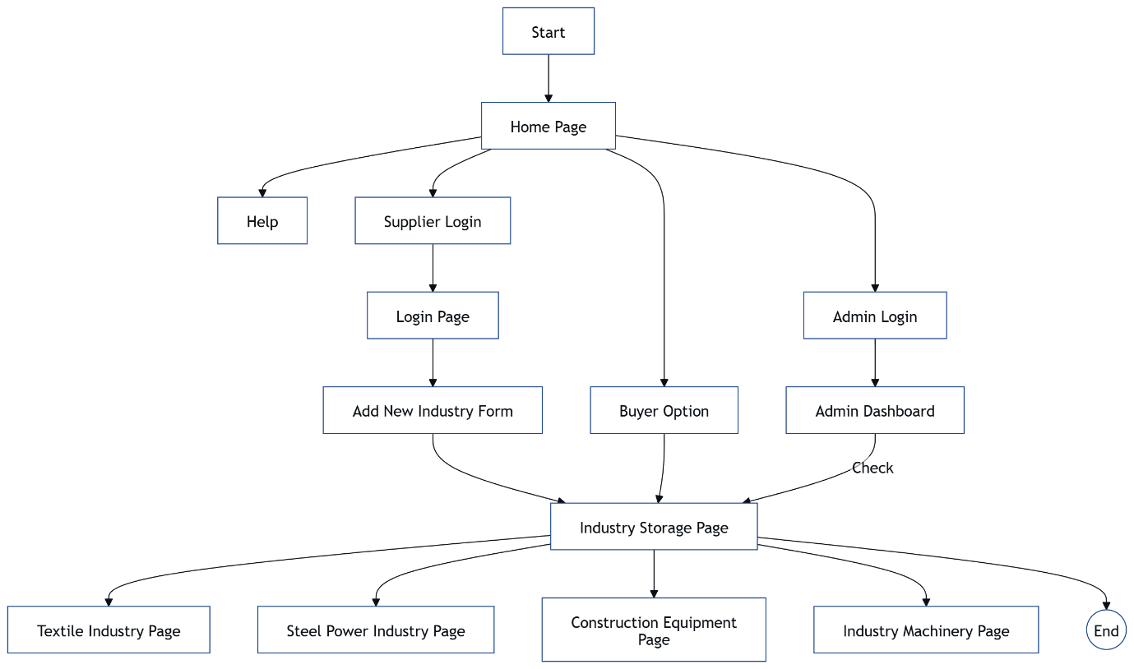

**Fig 4.4.6 Activity Diagram**

**4.5 IMPLEMENTATION**

**4.5.1 MODULES**

**1. Authentication Module**

* User registration & login
* Admin dashboard login
* Spring Security for role management

**2. Business Profile** **Module**

* Add/update/delete Business Profiles.
* Profile details (title, location, images, status)
* Categorize of Business Profiles (manufacturing, wholesale etc.)
* Display projects dynamically on website

**3. Product Listing Module**

* Add/edit/delete products
* List/update/remove products
* Product Details
* Categorize Products by Type
* Dynamic Display of Products

**4. Advertisement Module**

* Dynamic Advertisement Slideshow
* Admin Control of Ads

**5. Admin Panel (CMS) Module**

* Centralized Management for All Modules
* Rich Text Editor & Media Upload
* Role-Based Access Control

**6. Frontend with Thymeleaf**

* Dynamic Rendering of Content
* Styling with Tailwind CSS or Bootstrap
* SEO-Friendly Routes & Layout Fragments

**7. Testimonial Module**

* Client Feedback/Testimonials
* Admin Approval for Testimonials
* Carousel Display on Homepage

**8. Contact Module**

* Contact Form
* Backend Message Handling
* Google Maps Integration

**4.6 SCREENSHOTS**

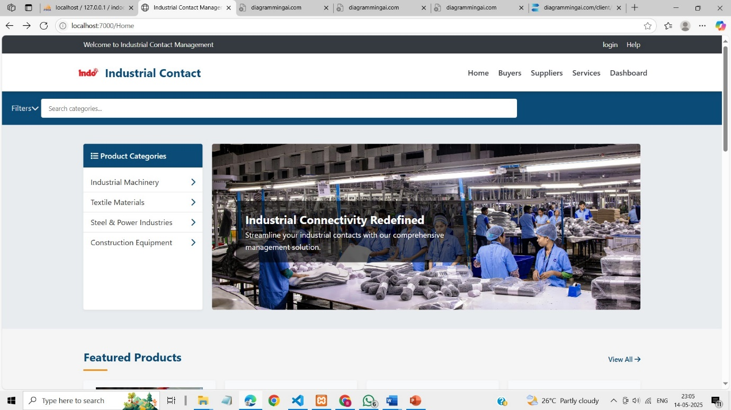

Fig: Home page

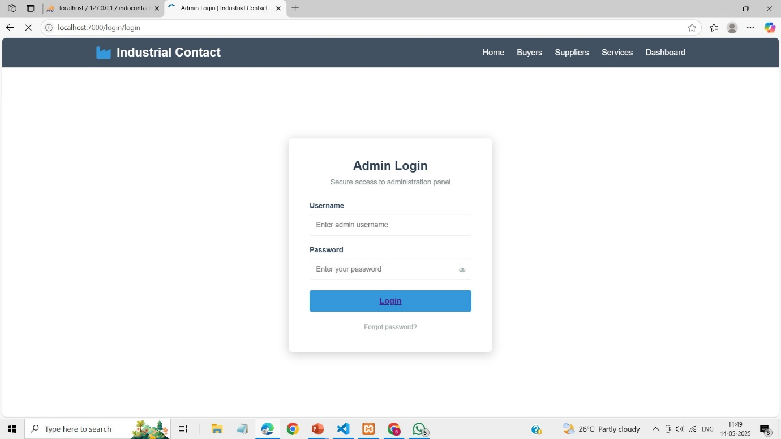

Fig: Home page

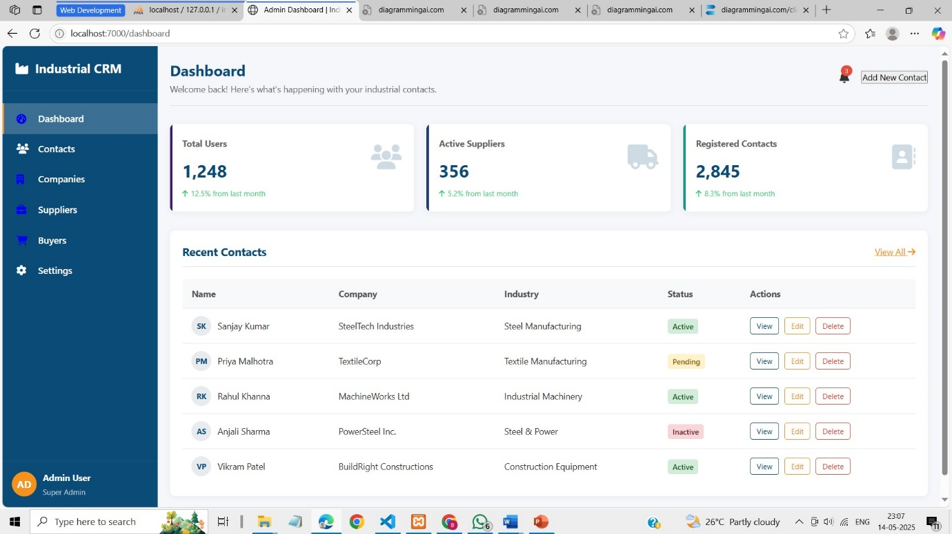

Fig: Home page

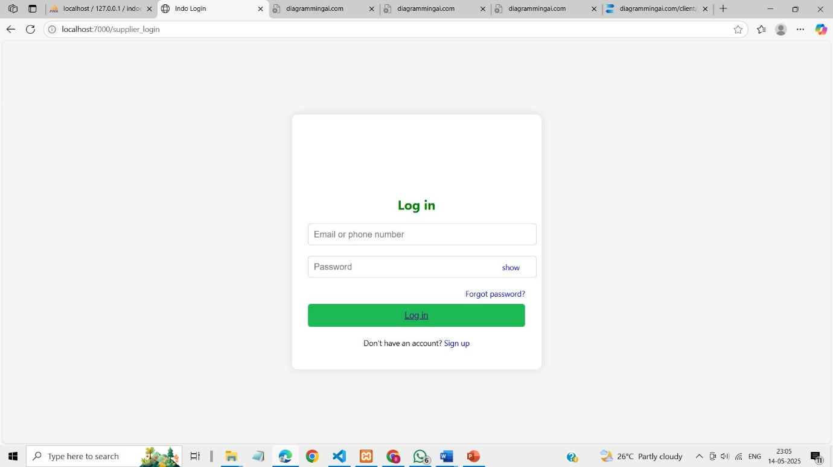

Fig: Home page

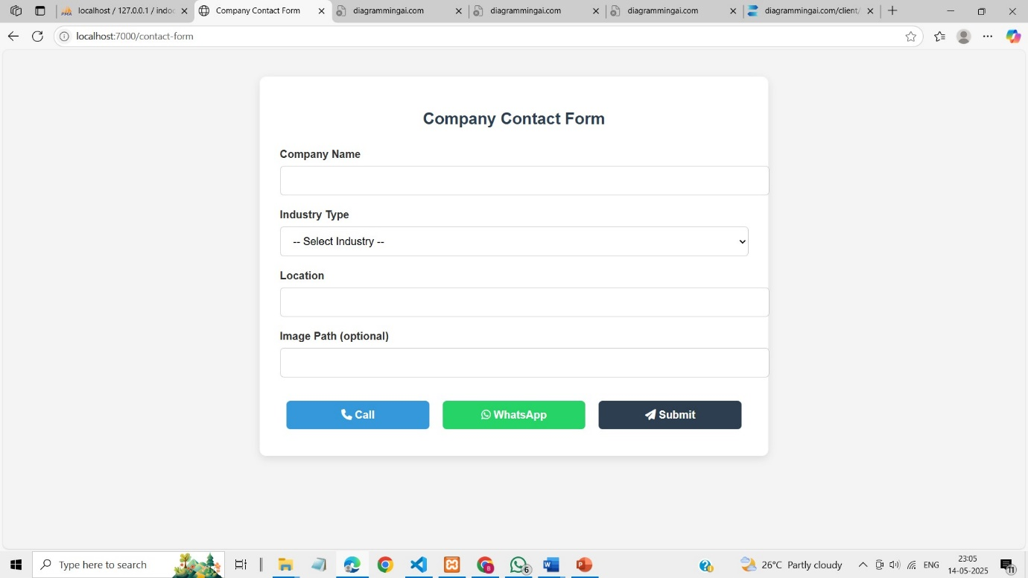

Fig: Home page

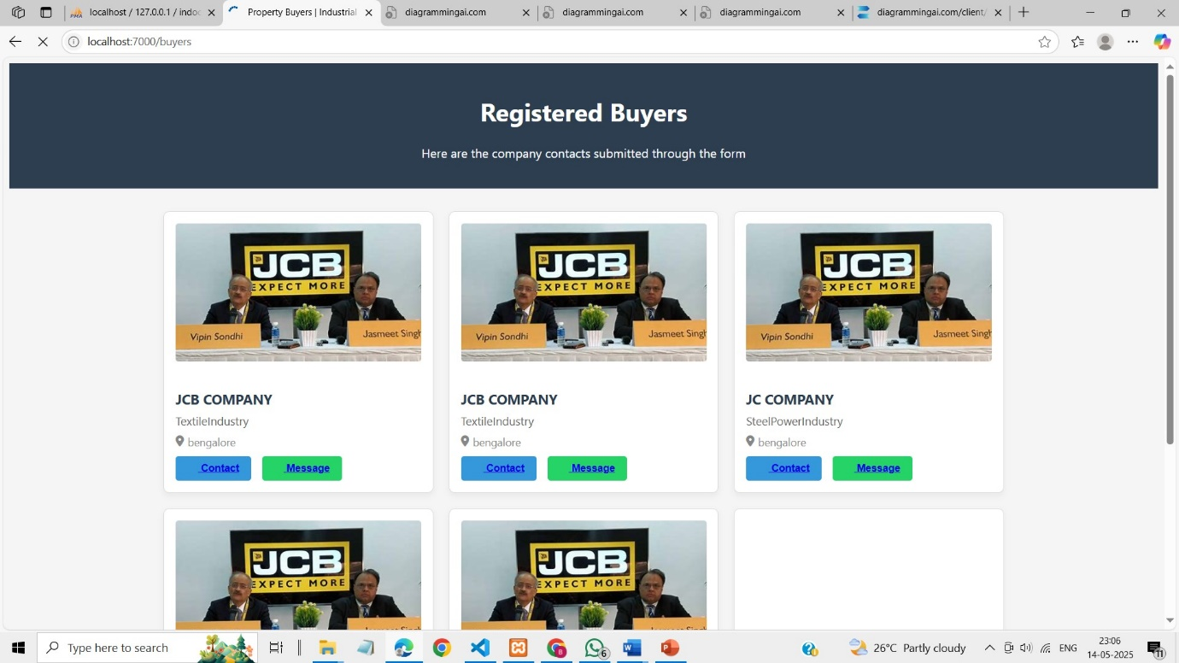

Fig: Home page

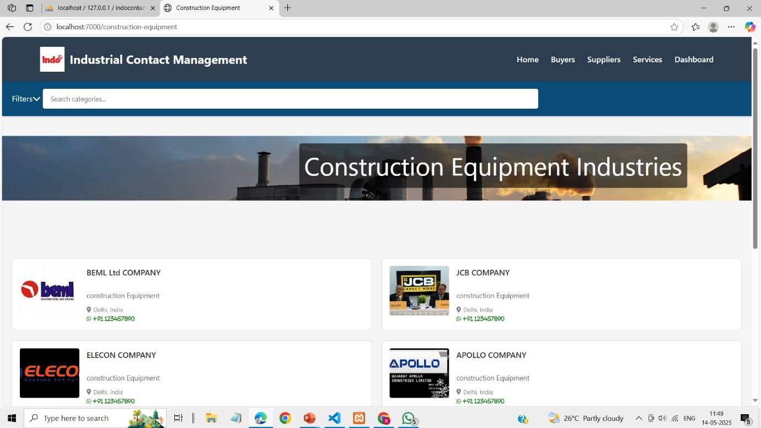

Fig: Home page

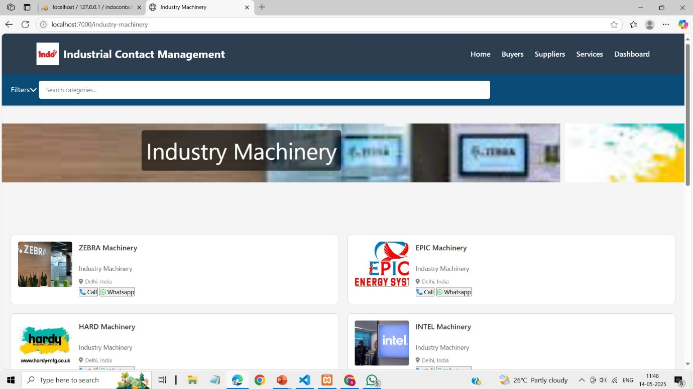

Fig: Home page

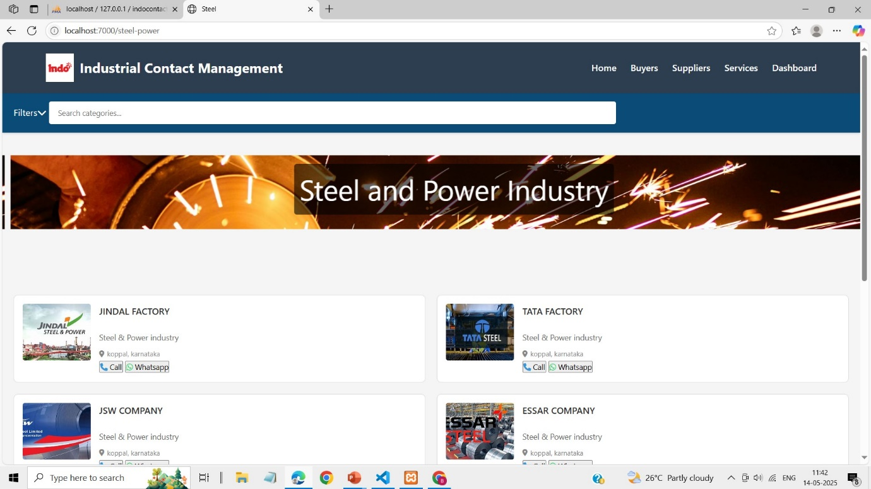

Fig: Home page

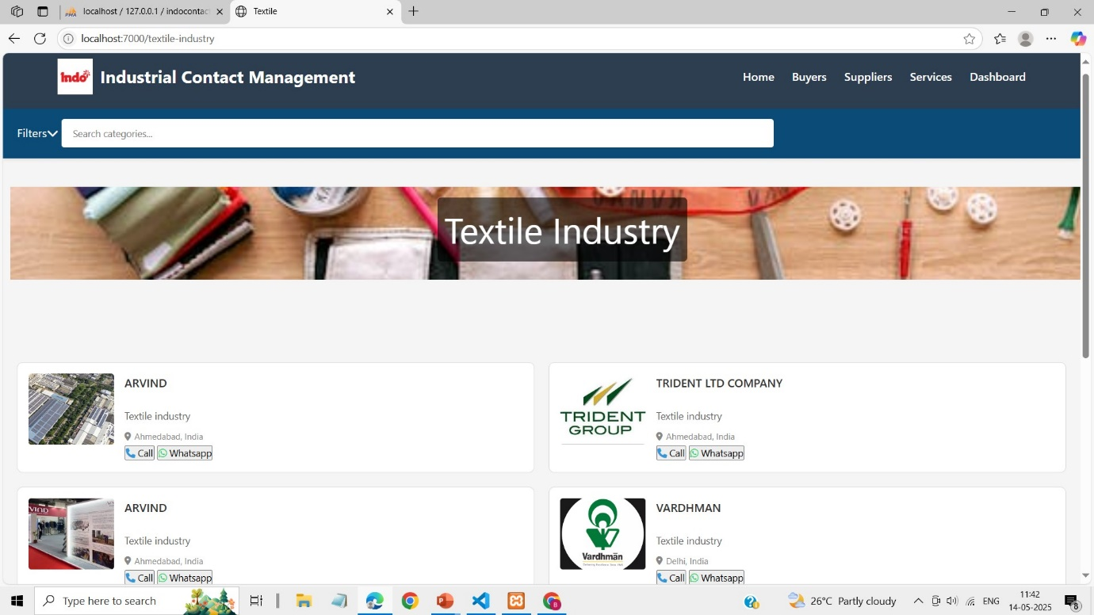

Fig: Home page

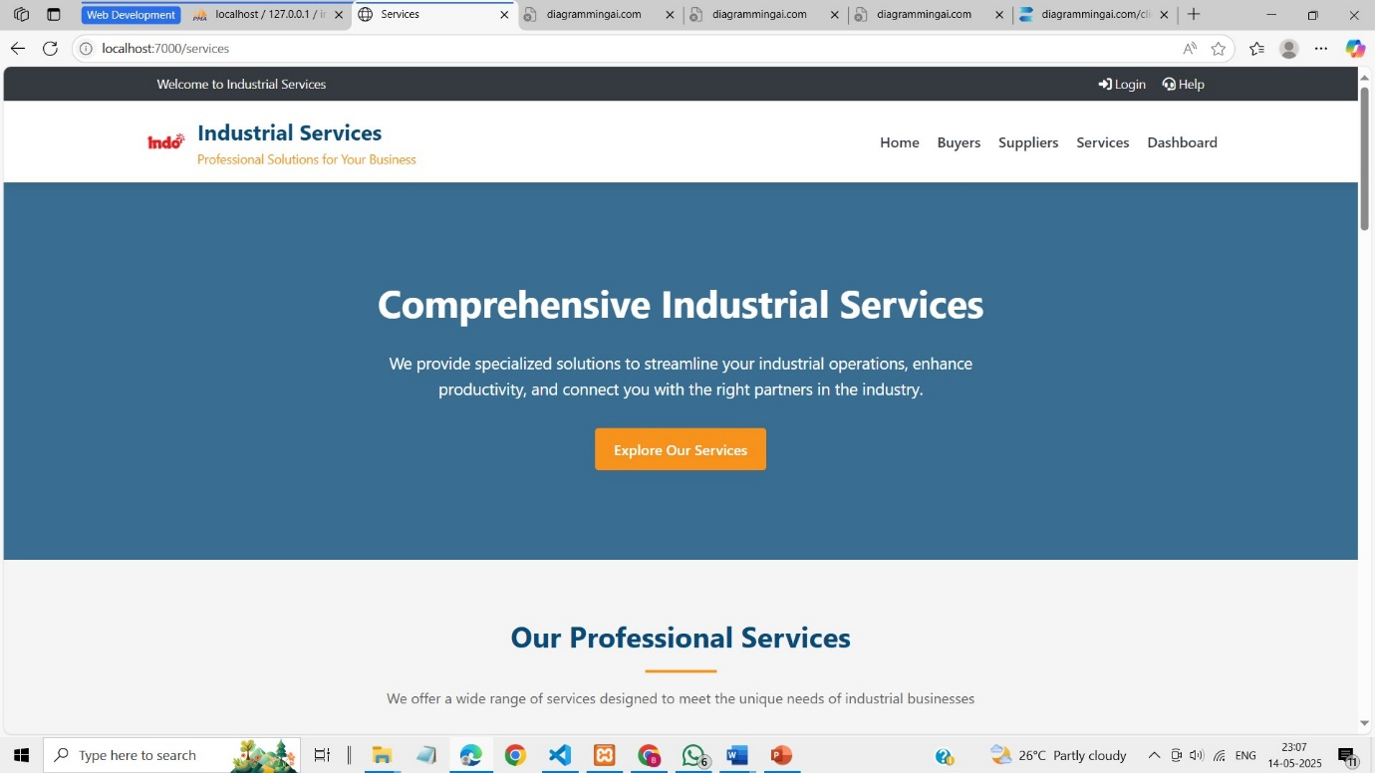

Fig: Home page

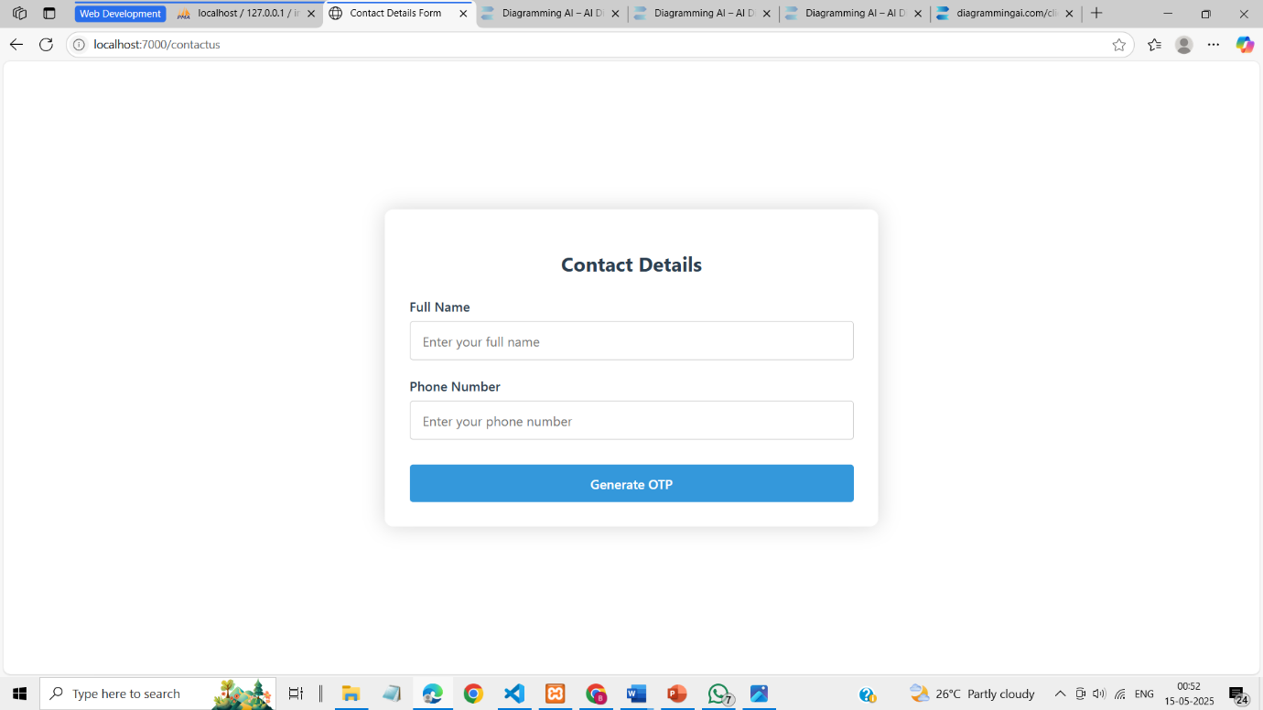

Fig: Home page

**CHAPTER 5**

**CONCLUSION**

In conclusion, the proposed INDO Contact Management system offers a comprehensive solution for businesses to efficiently manage and exchange product and contact information. By centralizing and securing user profiles, product listings, and business interactions, it simplifies the process of connecting manufacturers with potential buyers, fostering an organized and professional environment for business networking. The system’s features, such as secure registration, free trial contacts, and integrated payment gateways, not only enhance user experience but also introduce a sustainable revenue model. The inclusion of categorized listings, a user-friendly interface, and scalability ensures that the platform can grow and adapt to future needs. With a focus on security, efficiency, and user engagement, this system provides an innovative and reliable solution for modernizing business contact management, offering immense potential for expansion and long-term success.

**BIBLIOGRAPHY**

In conclusion, the proposed INDO Contact Management system offers a comprehensive and modern solution for managing business contacts and product information. By centralizing and securing user profiles, business details, and product listings, the platform significantly improves the efficiency of interactions between manufacturers and buyers. The system’s design incorporates user-friendly features such as secure registration, login, and structured profiles that allow businesses to present themselves professionally with detailed information, including industry type, product offerings, years of experience, and contact details.

The platform’s categorization system enables easy navigation, making it simpler for users to find specific products or industries. Buyers also benefit from a unique feature offering a free trial contact with manufacturers, allowing them to explore the platform’s capabilities before committing to full registration and payment. This approach introduces a sustainable revenue model while ensuring that only serious buyers continue to engage with the platform.

The inclusion of secure payment gateways ensures seamless and transparent transactions for both buyers and manufacturers, providing confidence in the platform’s reliability. The system’s scalability allows it to grow alongside user needs, handling increasing amounts of data and traffic efficiently. Its intuitive interface ensures that users across various devices can interact with the platform smoothly, whether they are on a desktop or mobile device.

**APPENDIX**

The Appendix of the INDO Contact Management system provides additional supporting information, documentation, and technical details that supplement the main body of the project. It includes system architecture diagrams, database schema designs, API documentation, and user interface wireframes, offering a deeper understanding of the platform’s structure and functionality. Additionally, the Appendix features test cases and performance metrics that validate the system's robustness and scalability, ensuring that the platform can handle increased user traffic and data load. Detailed user guides and instructions for both manufacturers and buyers are also included, helping them navigate the registration, profile creation, payment process, and product listing functionalities. Any relevant code snippets, third-party libraries, or external tools used in the development process are also outlined in the Appendix, providing transparency on the technical components involved in building and maintaining the system. By offering this additional layer of information, the Appendix serves as a comprehensive reference for developers, users, and stakeholders, aiding in the understanding and proper use of the INDO Contact Management platform.